6A^{th} Grade: Unit 4, Lesson 5

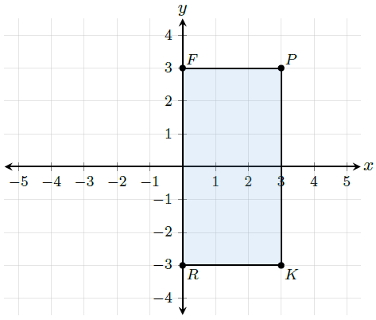
- What is the length of the line segment connecting points P and K?

6 units

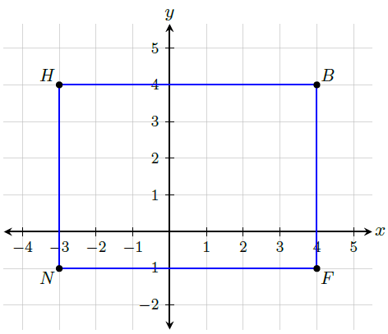
- What is the length of the line segment that connects points B and F?

5 units

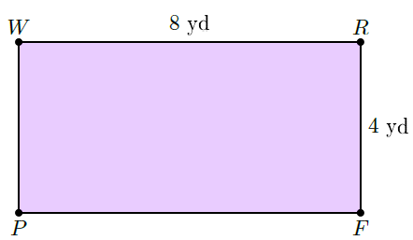
- What is the perimeter of the rectangle?

24 yards

